**DAILY ONLINE ACTIVITIES SUMMARY**

|  |  |  |  |  |  |  |  |
| --- | --- | --- | --- | --- | --- | --- | --- |
| **Date:** | **27/05/2020** | | | | **Name:** | **Rohan Vashista BM** | |
| **Sem & Sec** | **6th Sem & B** | | | | **USN:** | **4al17CS078** | |
| **Online Test Summary** | | | | | | | |
| **Subject** | | **SSCD Test2** | | | | | |
| **Max. Marks** | | **30** | | **Score** | | **19** | |
| **Certification Course Summary** | | | | | | | |
| **Course** | **Full Stack Web development** | | | | | | |
| **Certificate Provider** | | | **Udemy** | **Duration** | | | **20hrs** |
| **Coding Challenges** | | | | | | | |
| **Problem Statement:**  1. ython program to check if a number is palindrome  2. Python program to print all integers that aren't divisible either by 2 or 3 and lie between 1 and 50. | | | | | | | |
| **Status: completed** | | | | | | | |
| **Uploaded the report in Github** | | | | **yes** | | | |
| **If yes Repository name** | | | | <https://github.com/Rohanvasista/Coding-activities> | | | |
| **Uploaded the report in slack** | | | | **yes** | | | |

**Online test details**

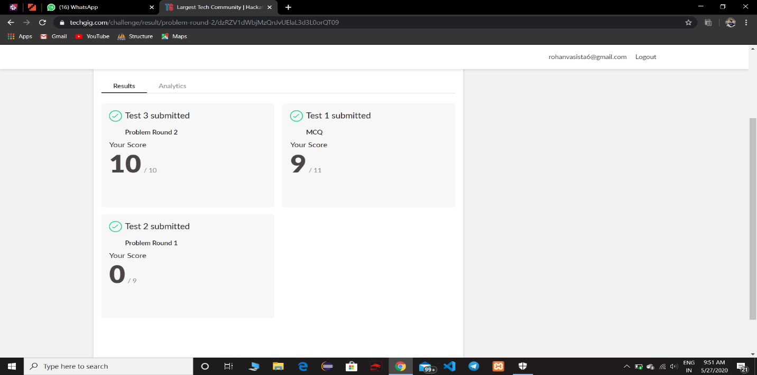

**Online Certification Details**

Completed modules

* Intoduction
* HTML
* CSS
* ReactJS
* Bootstrap
* Laravel

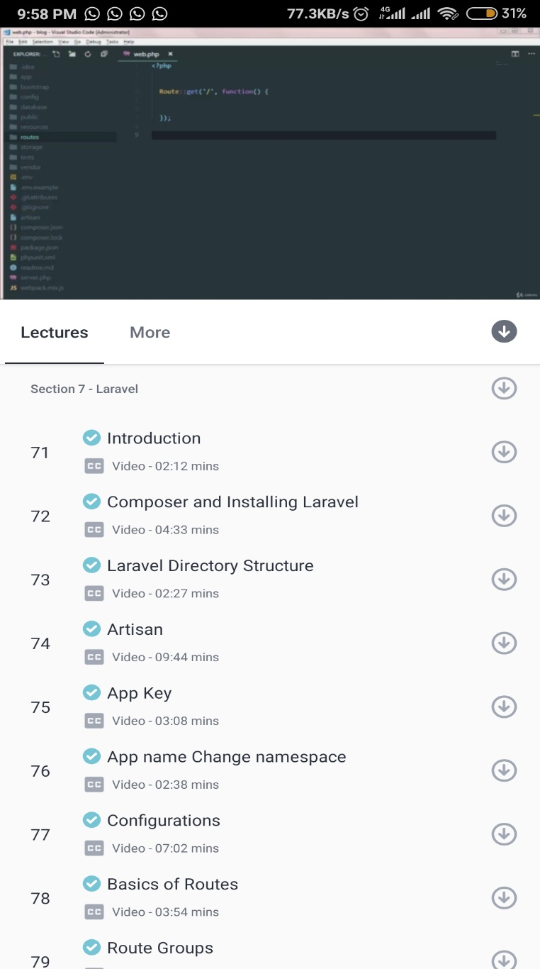

* Today I have learnt regarding Laravel which is php framework . I learnt about Laravel installation, Artisan and composer which is required mandatory to run and some basics of routes.

**Coding Challenge Details**

1. Python program to check if a number is palindrome

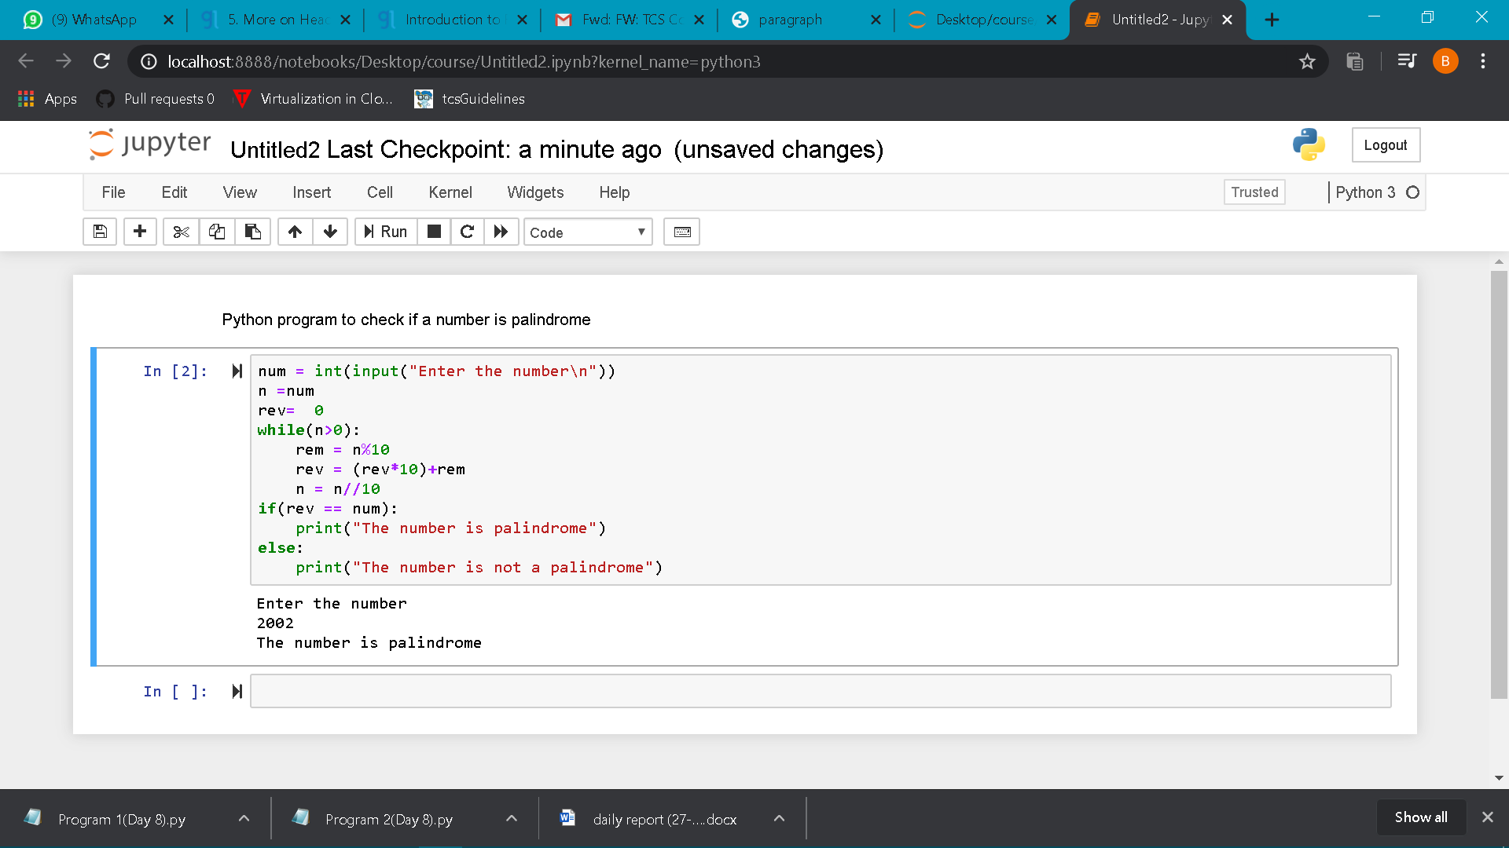

2. Python program to print all integers that aren't divisible either by 2 or 3 and lie between 1 and 50

